This is a population problem, not a sample mean problem, so I will find the Z score to determine how SD units 200 is from a mean of 191, given SD=22.4. I will then determine the probability for a Z score less than this and subtract the probability from 1 in order to get the probability of a total cholesterol greater than 200.

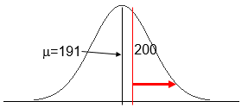
$$Z= \frac{x-μ}{σ}= \frac{200-191}{22.4}=0.40$$

P(Z<0.40) = pnorm(0.40) = 0.6554
P(Z>0.40 = 1-0.6554 = 0.3446
The probability of a total cholesterol greater than 200 in this population is 0.3446 = 34%.

